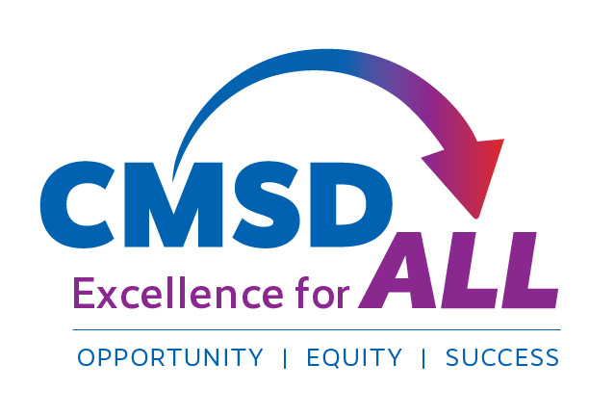

______________________________. 2020

Dear Parent/Guardian,

In an effort to improve meeting the social-emotional needs of students,

________________________________________ has partnered with ________________________________________ for consultative services. The services are designed to provide prevention services to classrooms, small groups or individual administration, offering consultation services as needed for students and families in need of social-emotional support. **If the consultative services are offered by the school, these services will be offered virtually until the district deems that it is safe to offer the services in a different format.**

The goal of consultation is to increase services for students and reduce and or eliminate barriers that can prevent students and families from accessing needed support for social-emotional development. If your child is in need of additional support we will contact you to discuss it further.

Your child’s Principal or Agency Mental Health Provider can support more specific details of this service at the given grade levels. School staff will seek parental consent for individual students who could benefit from individual consultation from the provider or if you feel your child is in need, you can request this consent from the principal.

If you need further information or have questions, please call ______________.

**If you DO NOT wish for your child to be eligible to participate in these services, please return the bottom portion of this notification to the office.** We look forward to implementing this program in an effort to expand services for students.

Sincerely,

____________________________

Principal

----------------------------------------------------------------------------------------------------

__________________________________/_________________________________

District/School Agency

( ) **I do not wish** for my child, ______________________________, to participate in the __________________________________ consultation program for the 2020-2021 school year.

Parent/Guardian Signature: _______________­­­_________________

Date: _­_________________________________________________

**CLEVELAND METROPOLITAN SCHOOL DISTRICT**

YOUR Address • Cleveland, OH 00000 • Office: 216.000.0000 • Fax: 216.000.0000

ClevelandMetroSchools.org